Project Design Phase-II
Data Flow Diagram & User Stories

Date | 11 June 2026
Team ID
Project Name | Medi book-Book a doctor
Maximum Marks | 4 Marks

Data Flow Diagrams:
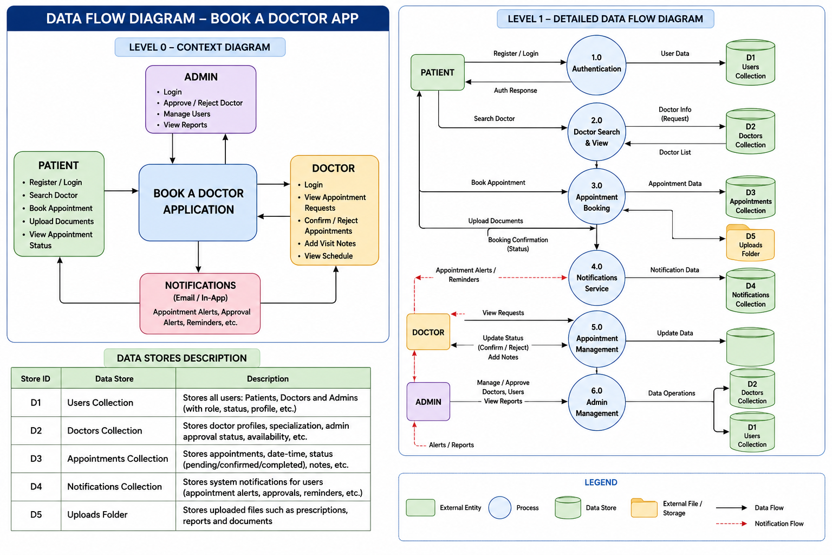
Level 0 — Context DFD (description — draw diagram in tool):
- External Entities: Patient, Doctor, Admin
- Central Process: MediBook Application
- Patient sends: Registration data, Login credentials, Appointment requests, Uploaded documents
- Doctor sends: Login credentials, Appointment status updates, Visit notes
- Admin sends: Login credentials, Doctor approval/rejection decisions
- System returns to Patient: JWT token, Doctor list, Appointment confirmations, Notifications
- System returns to Doctor: JWT token, Appointment requests, Patient documents
- System returns to Admin: JWT token, Pending applications, Platform statistics

Level 1 — Process breakdown:
- Process 1.0: User Authentication — handles register and login, generates JWT, validates roles
- Process 2.0: Doctor Management — stores/retrieves doctor profiles, handles apply-as-doctor flow
- Process 3.0: Appointment Booking — validates slot availability, creates booking, triggers notifications
- Process 4.0: Dashboard Management — serves role-specific data to Patient, Doctor, and Admin
- Process 5.0: Admin Control — handles doctor approvals, user management, platform analytics
User Stories
User Type | Epic | USN | User Story | Acceptance Criteria | Priority | Release
Patient | Registration | USN-1 | As a patient I can register with name, email, password, and role. | Account created and redirected to dashboard | High | Sprint-1
Patient | Registration | USN-2 | As a patient I can log in and receive a JWT token valid for 7 days. | JWT stored in localStorage, correct redirect | High | Sprint-1
Patient | Doctor Browsing | USN-3 | As a patient I can search and filter doctors by specialty and name. | Filtered list updates with each selection | High | Sprint-2
Patient | Appointment Booking | USN-4 | As a patient I can book an appointment in a 3-step flow. | Appointment saved with status: pending | High | Sprint-2
Patient | Document Upload | USN-5 | As a patient I can upload PDF or image reports during booking. | File saved in server/uploads, linked to appointment | High | Sprint-2
Patient | Dashboard | USN-6 | As a patient I can view upcoming and past appointments. | Correct data appears under each tab | High | Sprint-3
Patient | Cancel | USN-7 | As a patient I can cancel a pending appointment. | Status changes to cancelled, doctor notified | Medium | Sprint-3
Patient | Apply Doctor | USN-8 | As a patient I can apply to become a doctor. | Application created with status: pending | Medium | Sprint-4
Doctor | Dashboard | USN-9 | As a doctor I can see all appointment requests. | All appointments listed by status tab | High | Sprint-3
Doctor | Appointment Mgmt | USN-10 | As a doctor I can confirm or reject an appointment. | Status updates, patient notification sent | High | Sprint-3
Doctor | Consultation | USN-11 | As a doctor I can add visit notes and mark consultation complete. | Notes saved, status: completed | High | Sprint-3
Admin | Doctor Approval | USN-12 | As an admin I can approve or reject doctor applications. | Doctor role updated, notification sent | High | Sprint-4
Admin | User Mgmt | USN-13 | As an admin I can view all users and toggle their active status. | isActive flag updated in database | Medium | Sprint-4
Admin | Analytics | USN-14 | As an admin I can view platform-wide statistics. | Counts of users, doctors, appointments shown | Medium | Sprint-4

